GENERAL CONFEDERATION OF LABOR OF VIETNAM

**TON DUC THANG UNIVERSITY**

**FACULTY OF INFORMATION TECHNOLOGY**



**THE FINAL REPORT OF ADVANCE WEB PROGRAMMING**

**ELECTRONIC WALLET**

Instructing Lecturer: **Ph.D. VU DINH HONG**

Student’s Name: **TO HOANG MINH QUAN – 520H0671**

**NGUYEN NHUT HUY– 520H0644**

**HUA TUAN HAO – 520H0530**

**NGO GIA PHAT – 519H0113**

Course**: 24 - 23**

Group**: 6**

**HO CHI MINH CITY, 2022**

GENERAL CONFEDERATION OF LABOR OF VIETNAM

**TON DUC THANG UNIVERSITY**

**FACULTY OF INFORMATION TECHNOLOGY**

**THE FINAL REPORT OF ADVANCE WEB PROGRAMMING**

**ELECTRONIC WALLET**

Instructing Lecturer: **Ph.D. VU DINH HONG**

Student’s Name: **TO HOANG MINH QUAN – 520H0671**

**NGUYEN NHUT HUY– 520H0644**

**HUA TUAN HAO – 520H0530**

**NGO GIA PHAT – 519H0113**

Course**: 24 - 23**

Group**: 6**

**HO CHI MINH CITY, 2022**

# THE REPORT WAS COMPLETED AT TON DUC THANG UNIVERSITY

We pledge that this is a product of our project under the guidance of a Ph.D. Vu Dinh Hong. The content of the research, and results on this subject are honest and have not been published in any form before. The data in the tables used for the analysis, comment, and evaluation were collected by the authors themselves from various sources indicated in the reference section.

In addition, many comments and assessments as well as data from other authors and organizations have been used in the project, with references and annotations.

**If any fraud is found, I am fully responsible for the content of my report.** Ton Duc Thang University is not involved in any copyright infringement or copyright infringement in the course of implementation (if any).

*Ho Chi Minh, December 5th, 2022*

*Author*

*(sign and write full name)*

*Tô Hoàng Minh Quân*

*Nguyễn Nhựt Huy*

*Hứa Tuấn Hào*

*Ngô Gia Phát*

EVALUATION OF INSTRUCTING LECTURER

**Confirmation of the instructor**

_______________________________________________________________________________________________________________________________________________________________________________________________________________________________________________________________________________________________________________________________________________________________________________________________________________

Ho Chi Minh City, 2022

(sign and write full name)

**The assessment of the teacher marked**

_______________________________________________________________________________________________________________________________________________________________________________________________________________________________________________________________________________________________________________________________________________________________________________________________________________

Ho Chi Minh City, 2022

(sign and write full name)

# 

**FIGURES:**

Figure 1. Login Page 1

Figure 2. Register Page 1

Figure 3. Reset Password Page 2

Figure 4. Confirm New Password At First Login 2

Figure 5. Change Password Page 3

Figure 6. Home Page 3

Figure 7. Deposit Page 4

Figure 8. Withdraw Page 4

Figure 9. Transfer Page 5

Figure 10. Buy Phone Card Page 5

Figure 11. History Page 6

Figure 12. History Detail 6

Figure 13. Profile User Page 7

Figure 14. Transaction Page Admin 7

Figure 15. Admin Activated Accounts Page 8

Figure 16. Admin Disable Accounts Page 8

Figure 17. Admin Waiting Vertify Accounts Page 9

Figure 18. Admin Locked Accounts Page 9

Figure 19. Home Page Mobile 10

Figure 20. Deposit Page Mobile 11

Figure 21. Withdraw Page Mobile 12

Figure 22. Transfer Page Mobile 13

Figure 23. Phone Card Page Mobile 14

Figure 24. History Page Mobile 15

# INTERFACES DESIGN

Note: We do not use figma to design, access link youtube to follow clearly:

<https://www.youtube.com/watch?v=pCai4mB-Gng>

**1.1. On the computer/laptop:**

- Login: using sign in into website

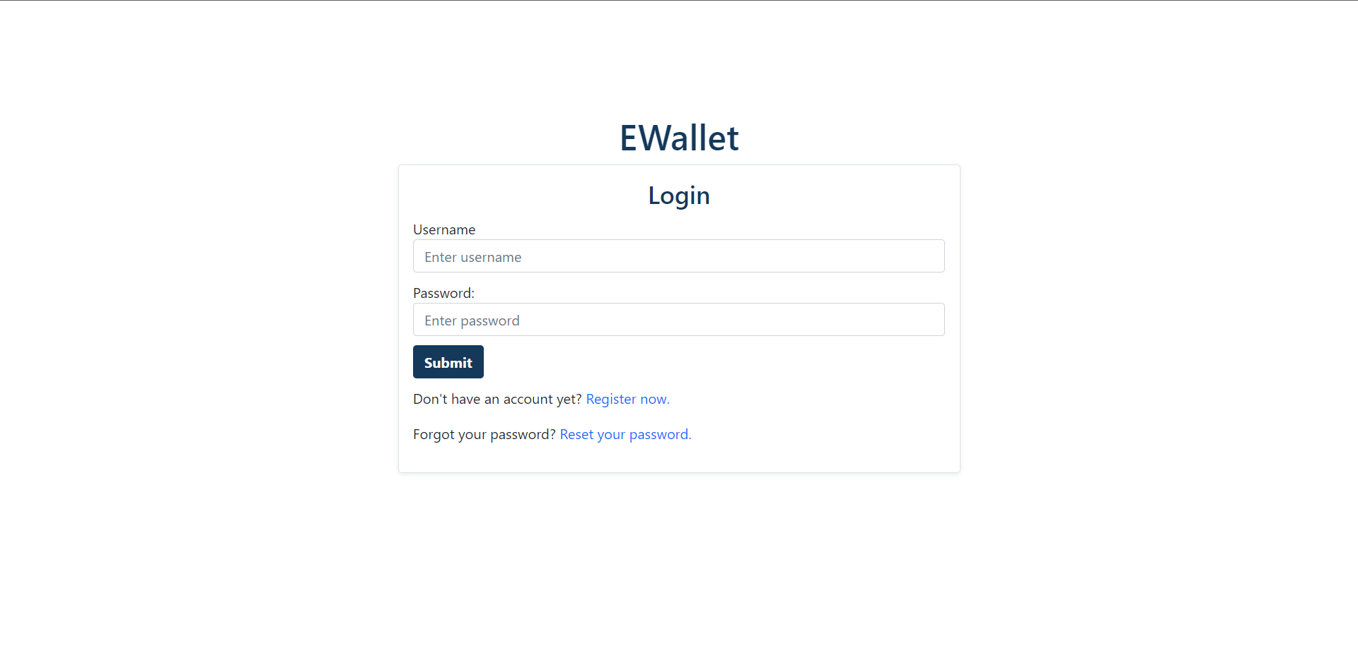

Figure . Login Page

- Register: sign up a new account

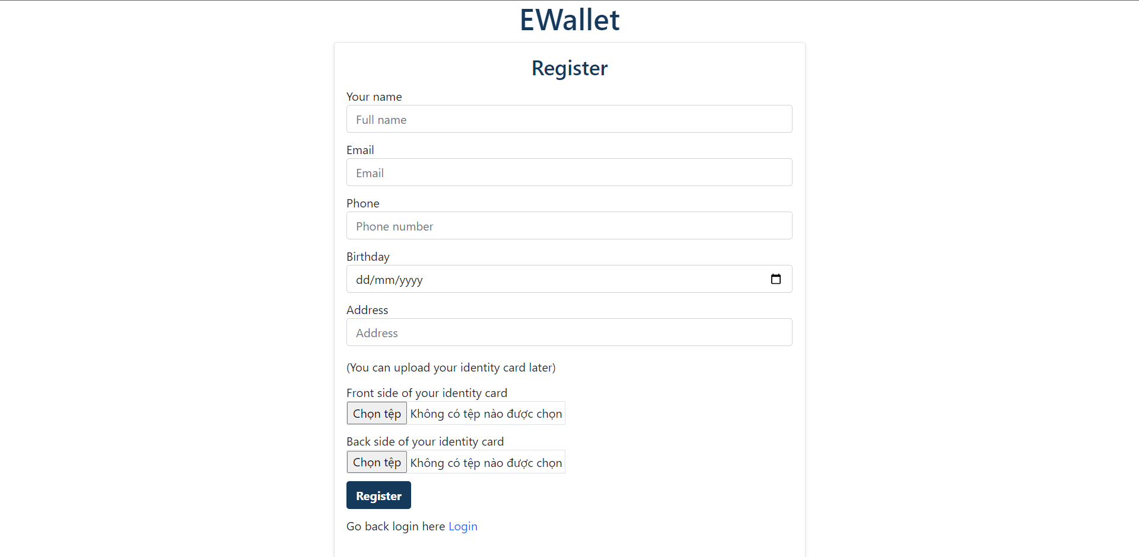

Figure . Register Page

- Reset Password: using reset password when user fogot current password

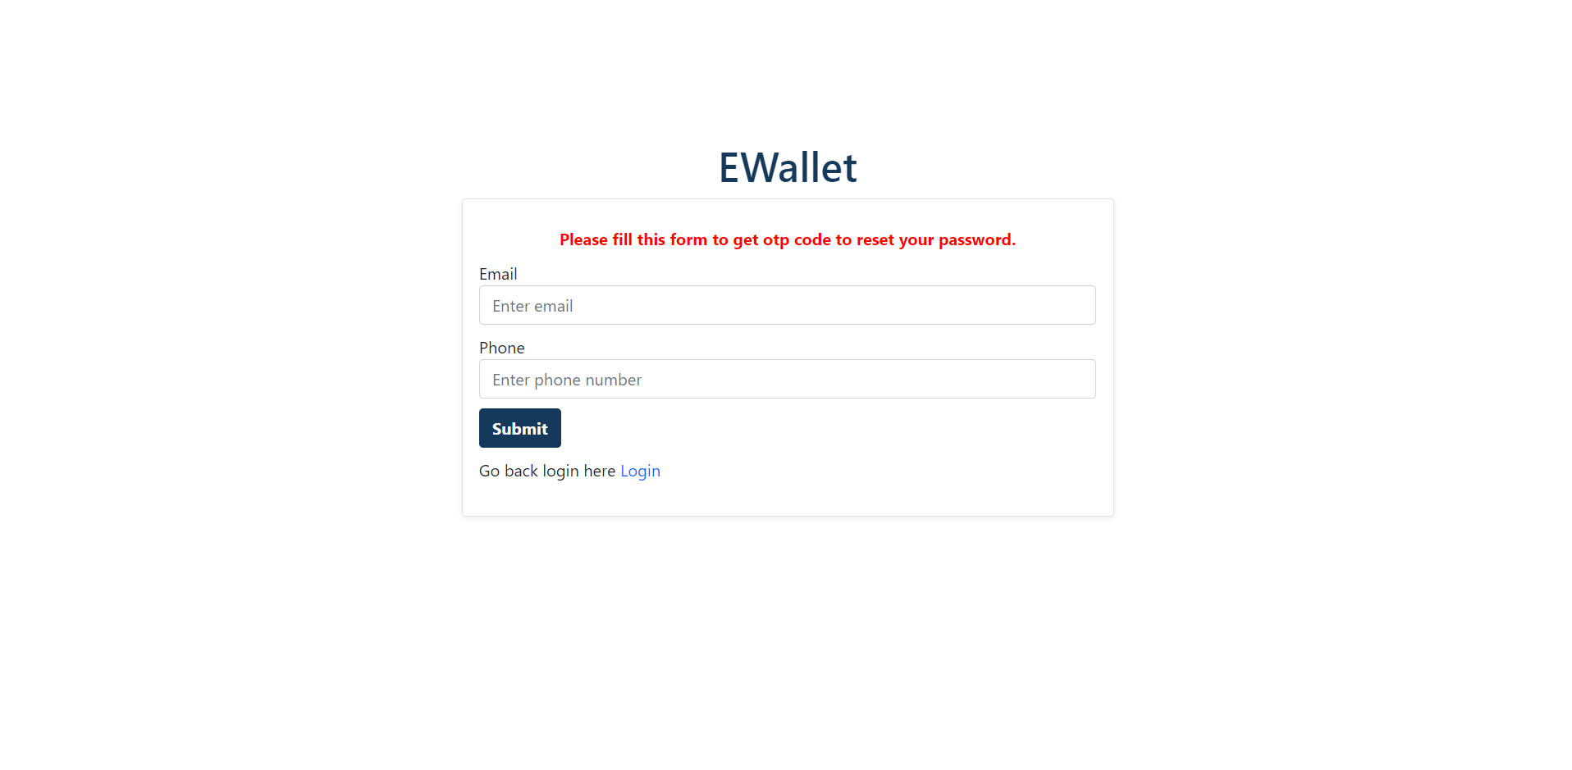

Figure . Reset Password Page

- Confirm New Password: using change password in the first sign in into website

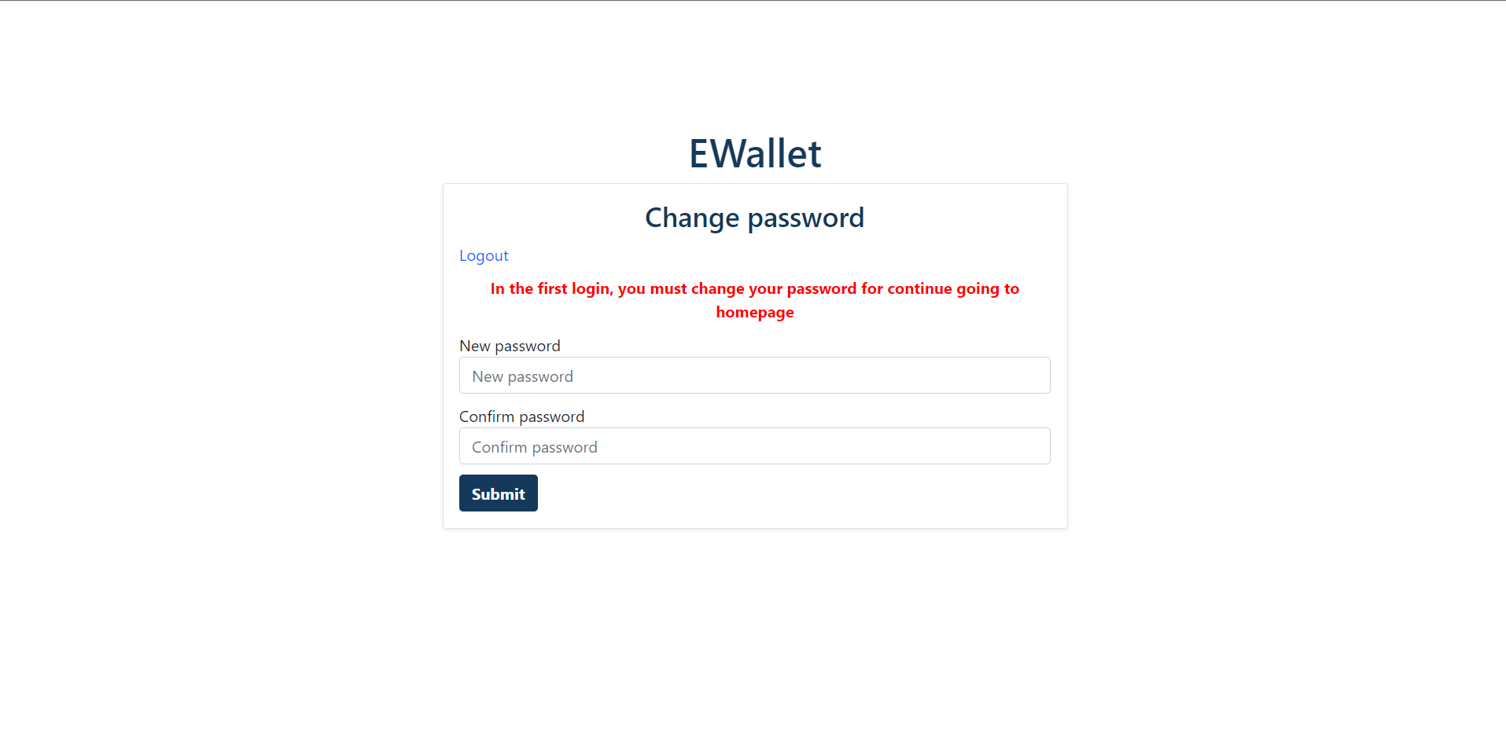

Figure . Confirm New Password At First Login

- Change Password: user want to change the current password, they can be direct to this page

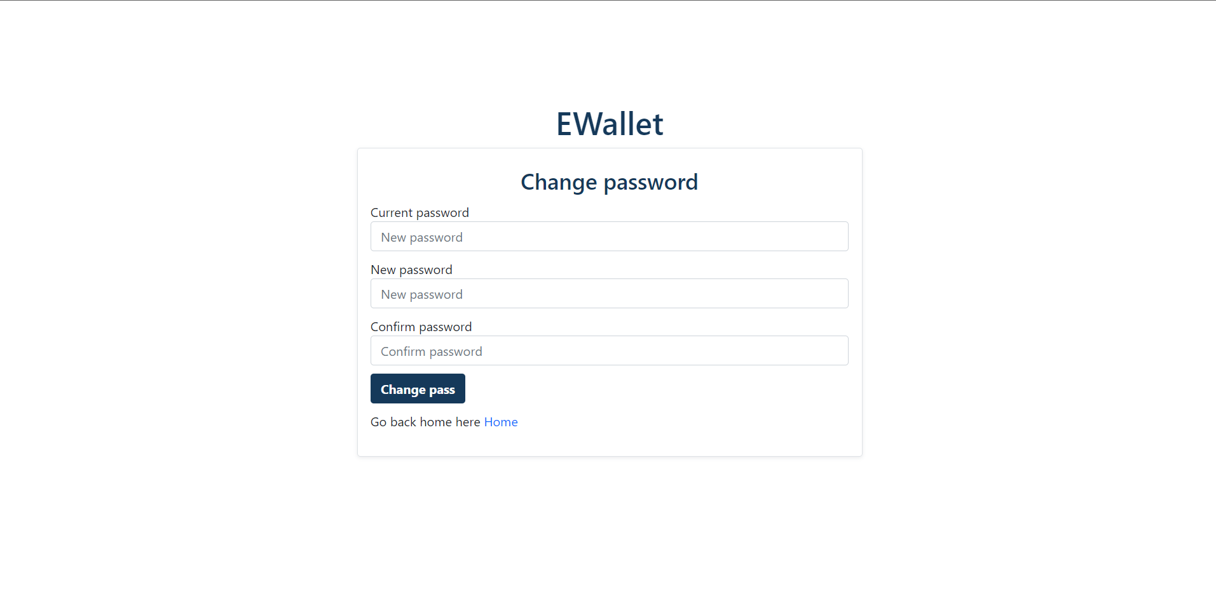

Figure . Change Password Page

- Home: home page when sign in successful

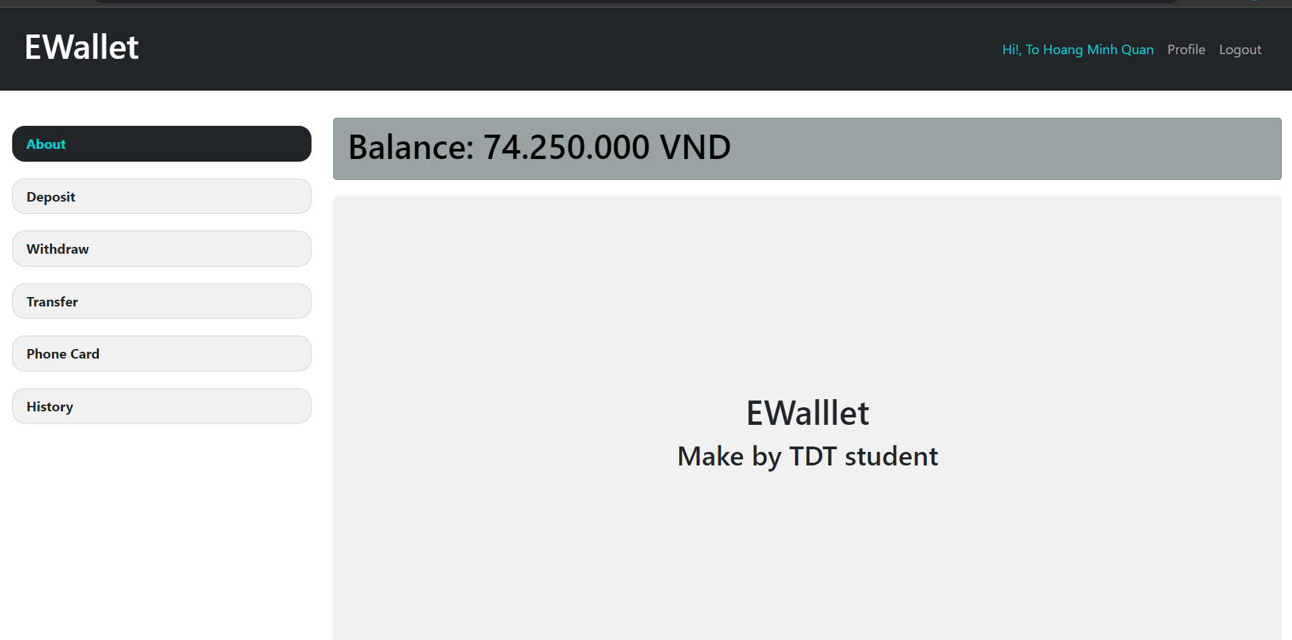

Figure . Home Page

- Deposit: used to deposit money into the account.

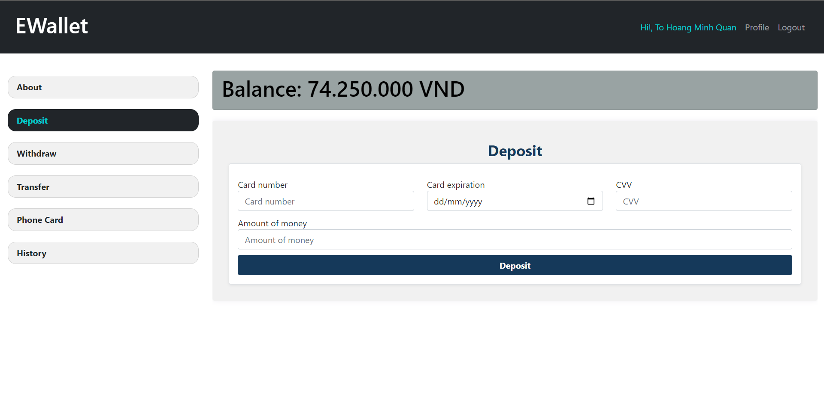

Figure . Deposit Page

- Withdraw: used to withdraw money out the wallet

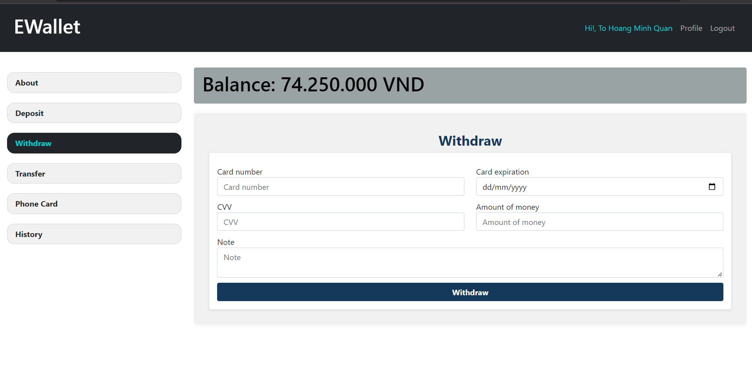

Figure . Withdraw Page

- Transfer: used to transfer money to another user or wallet

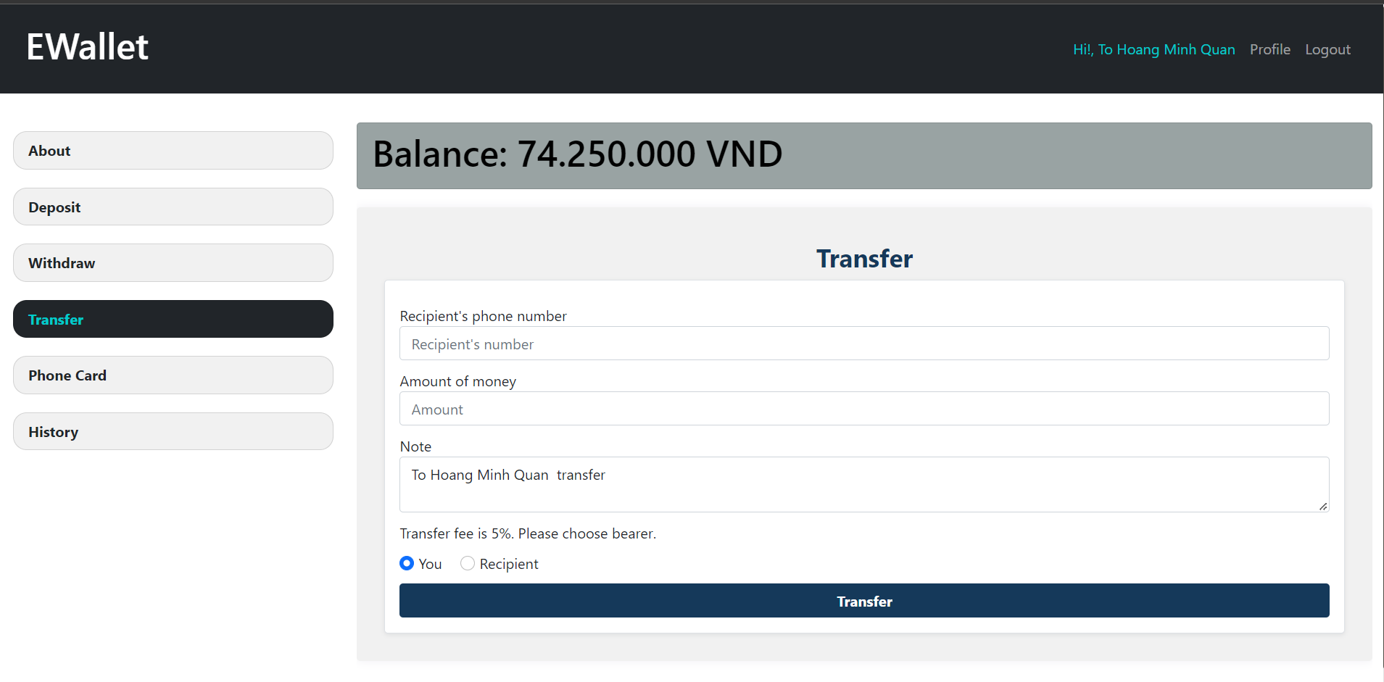

Figure . Transfer Page

- Phone Card: using to buy phone cards with many brand.

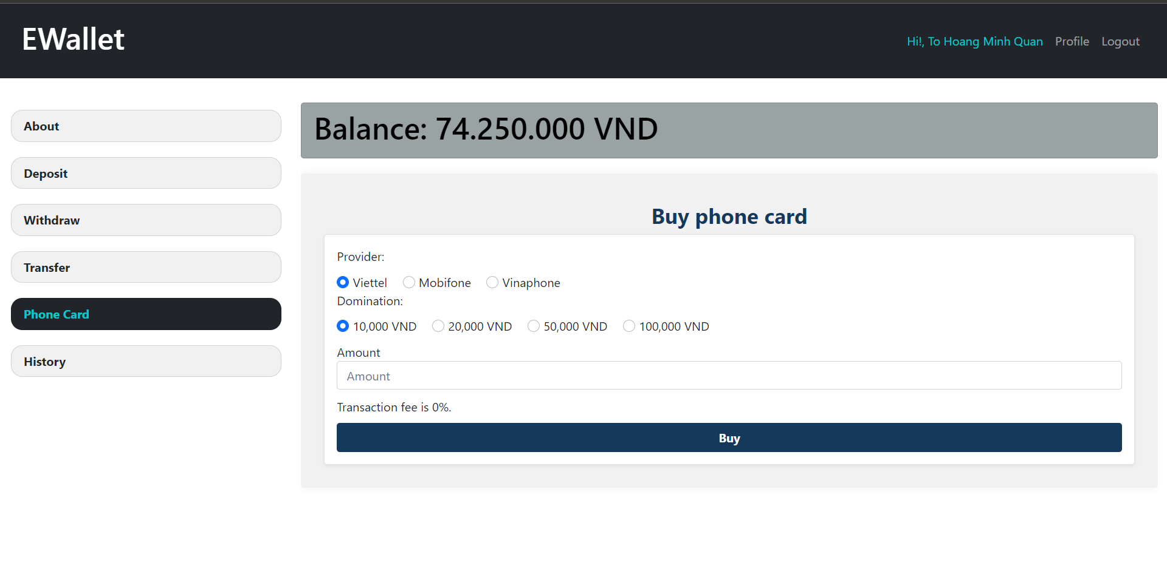

Figure . Buy Phone Card Page

- History: using to follow history transaction or deposit of user.

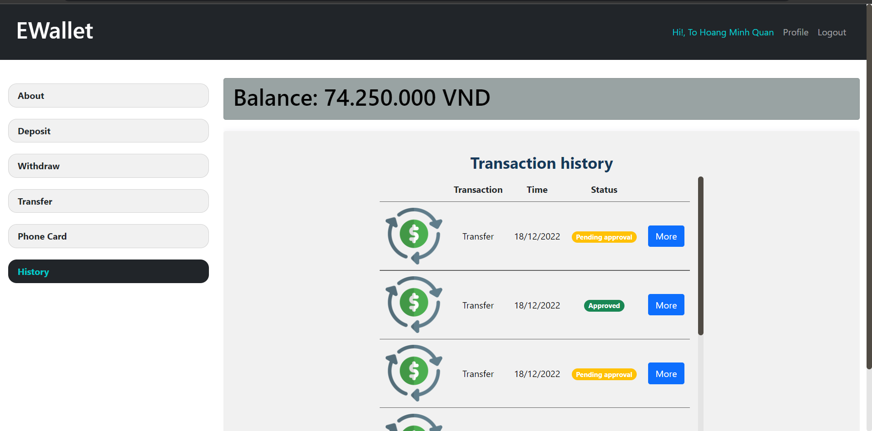

Figure . History Page

- History Details User: using to follow history details transaction or deposit of user.

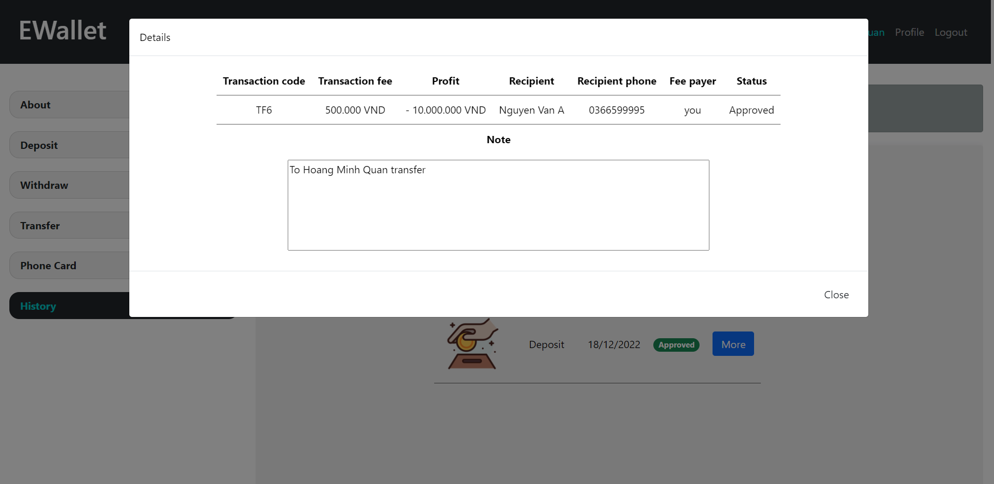

Figure . History Detail

- Profile User: see information about user include email, phone, address, indentity card

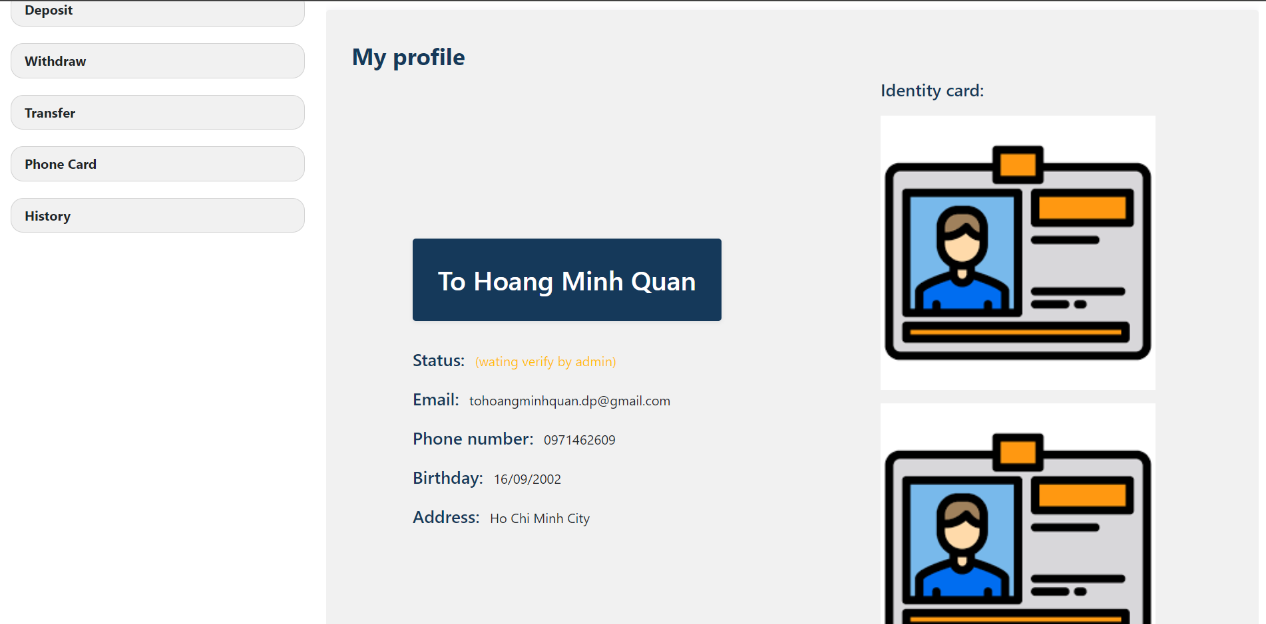

Figure . Profile User Page

- Admin Transactions: manage and approval the transaction from users in condition the money greater than 5 millions or equals.

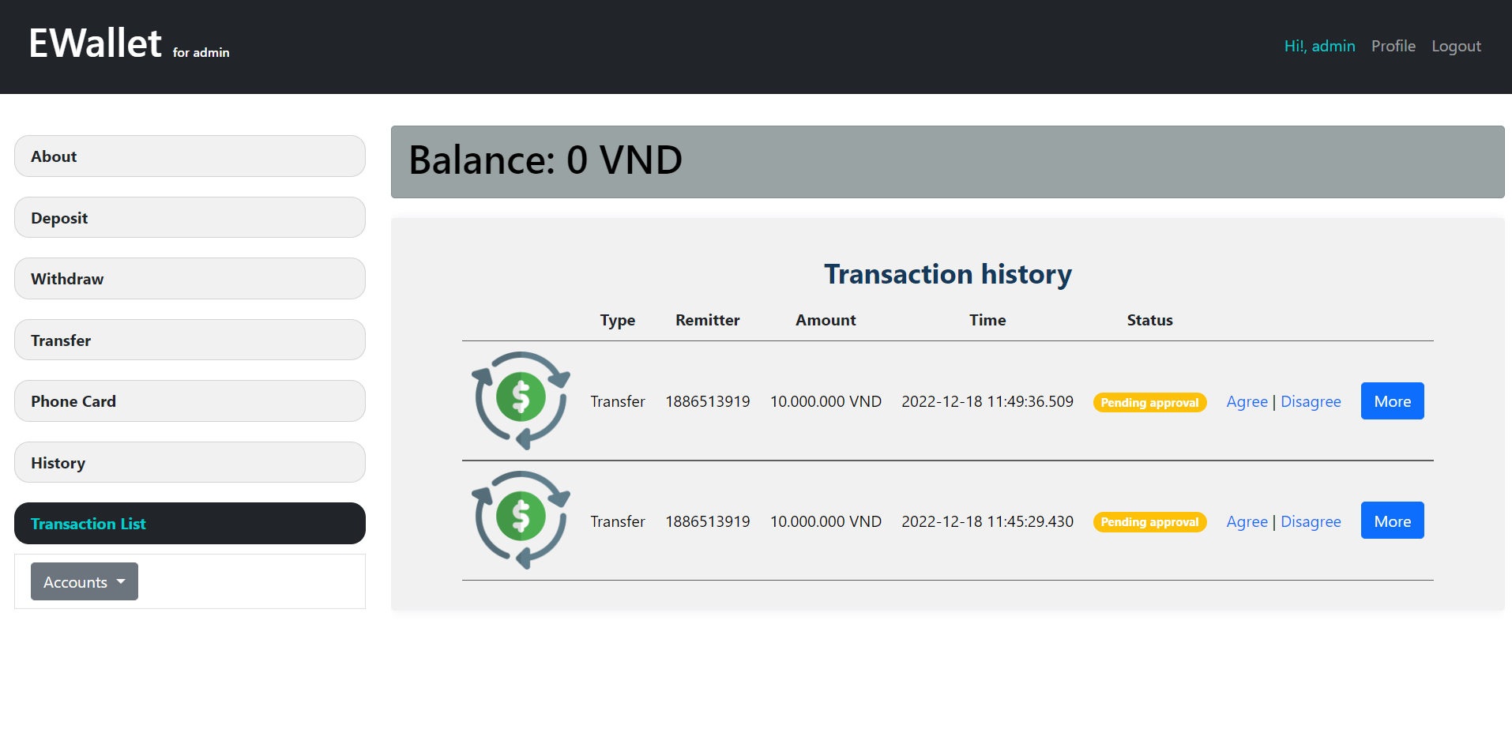

Figure . Transaction Page Admin

- Admin Activated Accounts: managed the account was activated

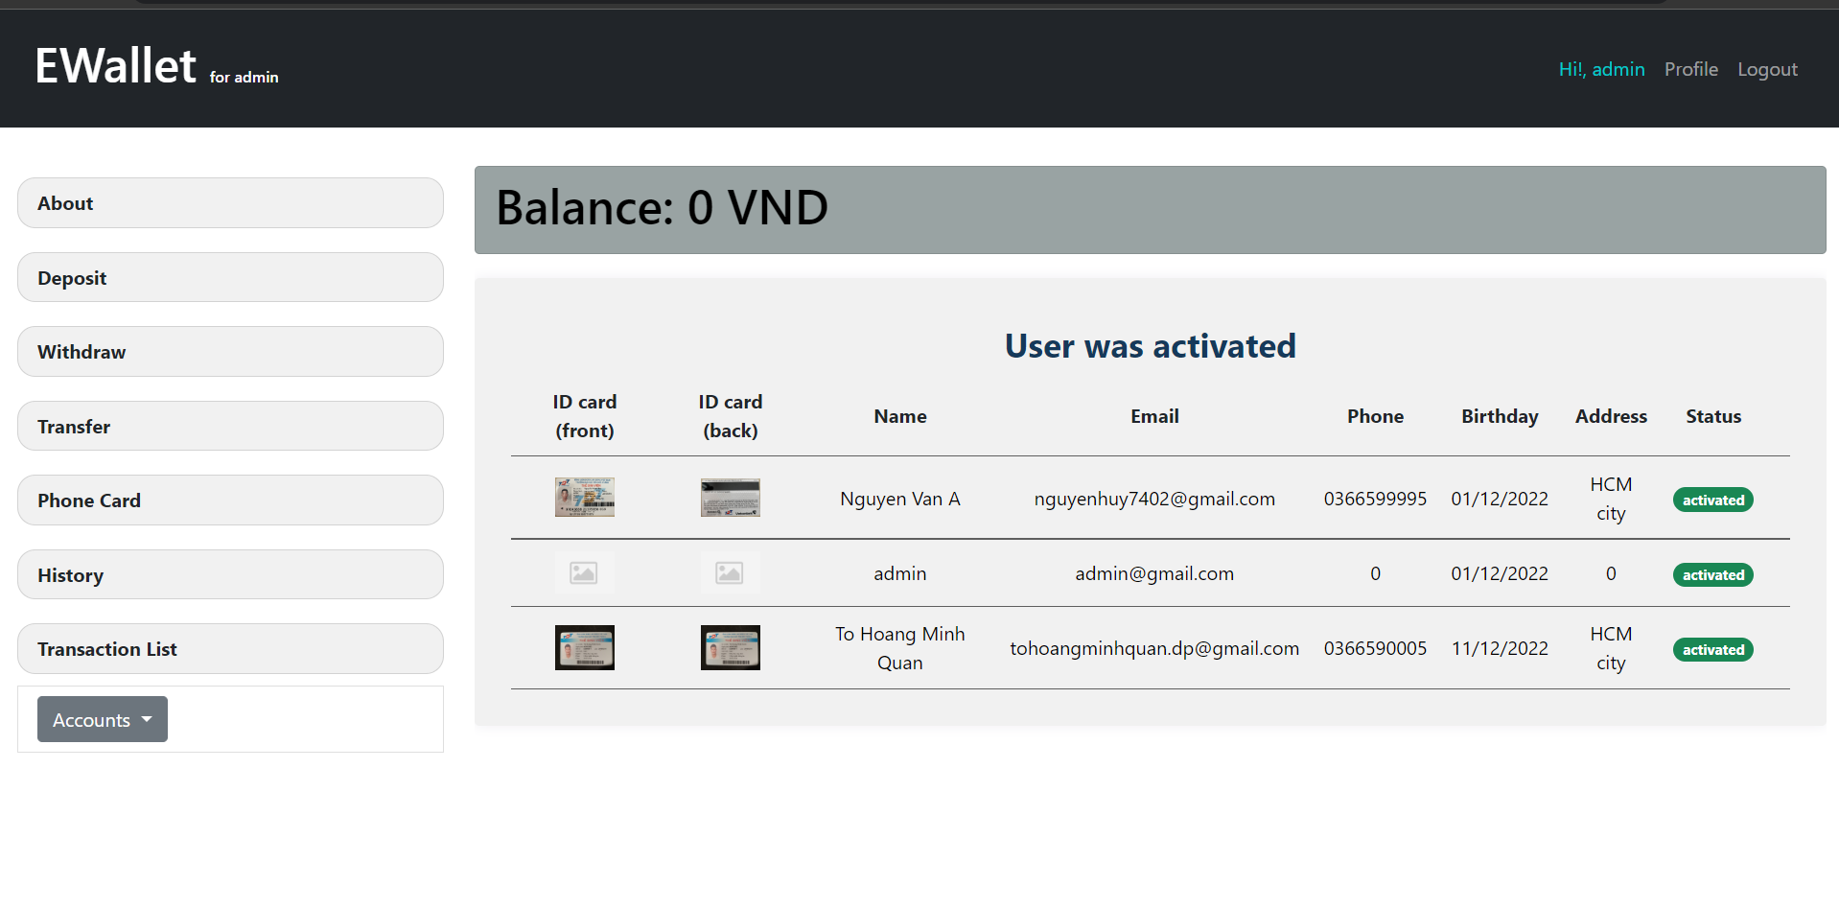

Figure . Admin Activated Accounts Page

- Admin Disable Accounts: managed the account was disabled

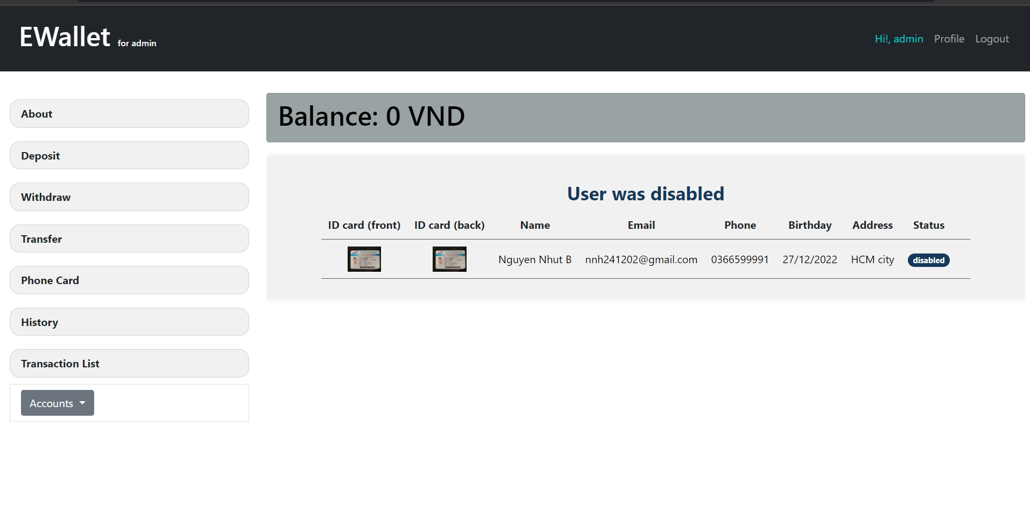

Figure . Admin Disable Accounts Page

- Admin Waiting Vertify Accounts: managed the account are waiting to verify or disable in case information wrong, or request in case the indentity card not correct

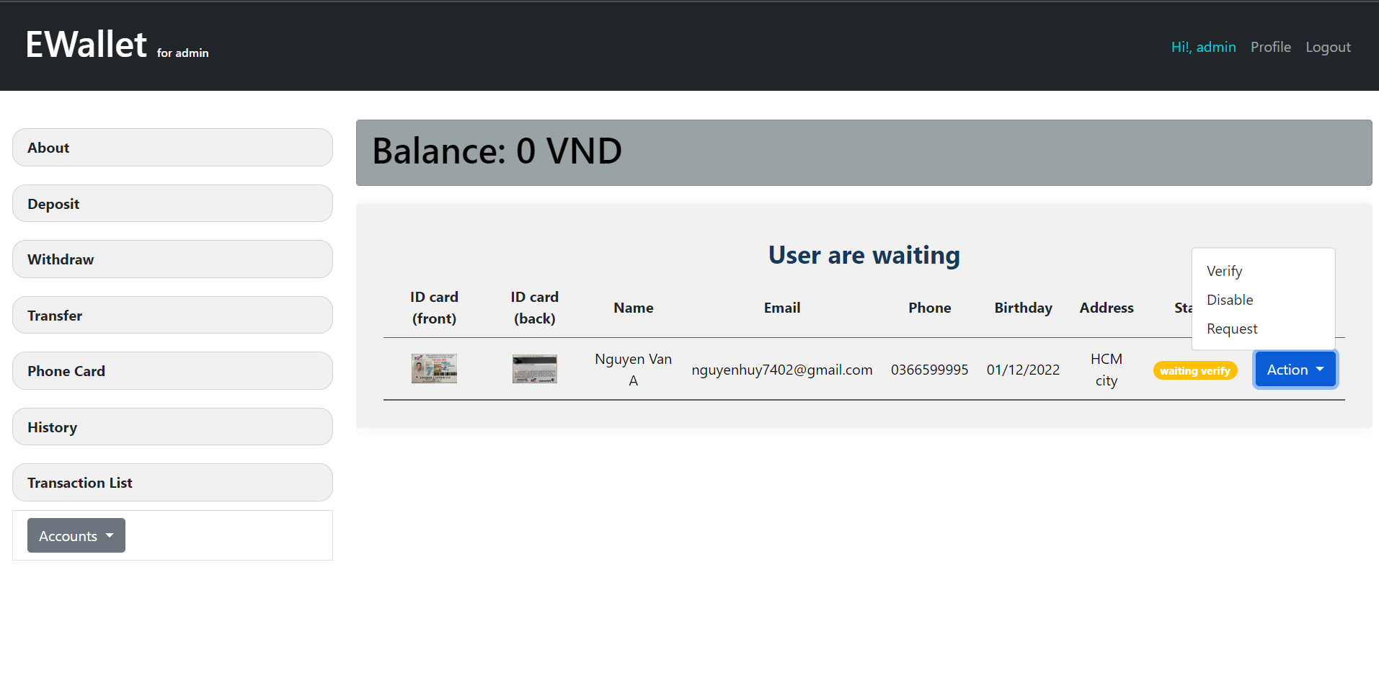

Figure . Admin Waiting Vertify Accounts Page

- Admin Locked Accounts: managed the account was locked

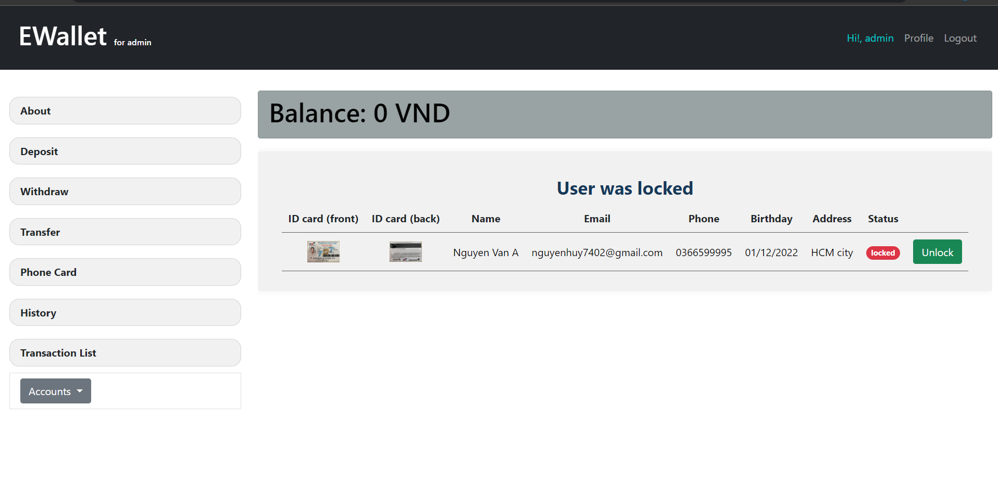

Figure . Admin Locked Accounts Page

**1.2. On the mobile:**

- Home screen:

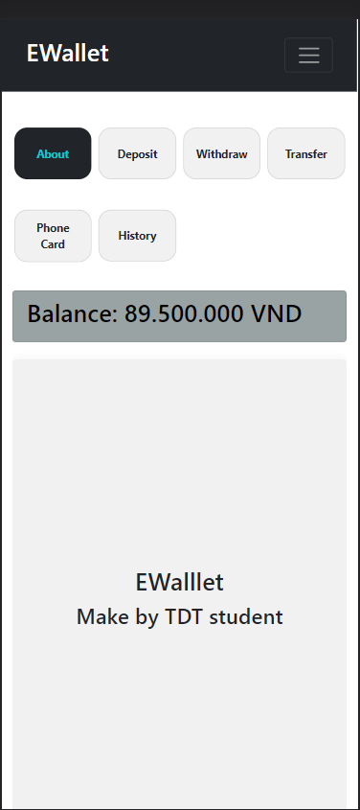

Figure . Home Page Mobile

- Deposit screen:

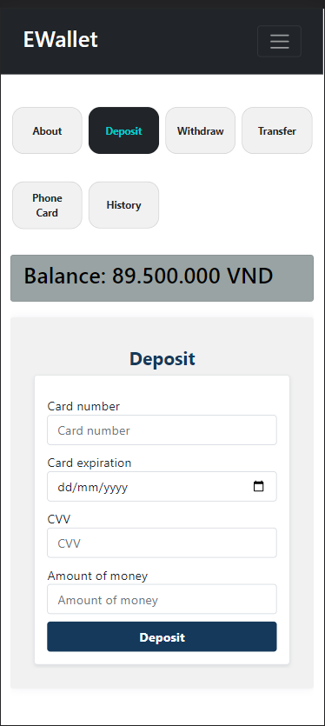

Figure . Deposit Page Mobile

- Withdraw screen

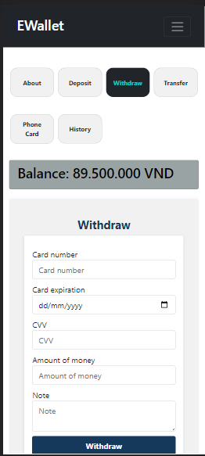

Figure . Withdraw Page Mobile

- Transfer screen

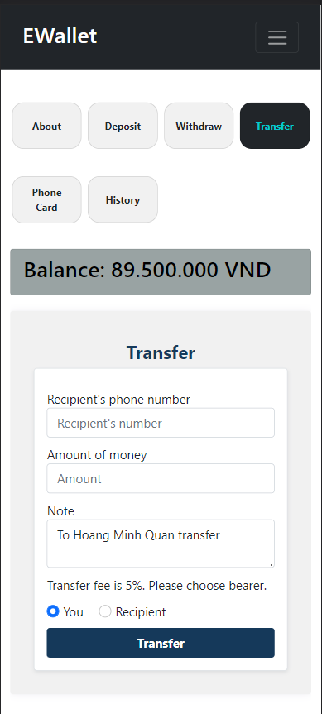

Figure . Transfer Page Mobile

- Phone card screen

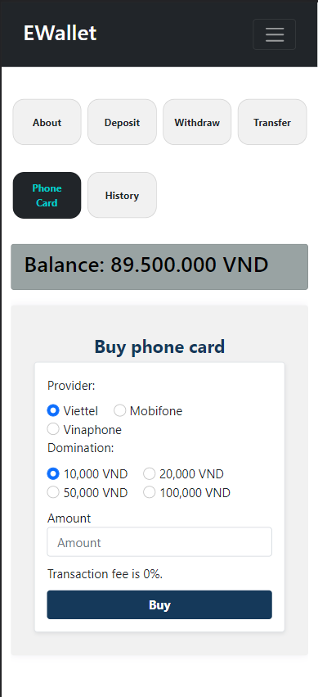

Figure . Phone Card Page Mobile

- History screen

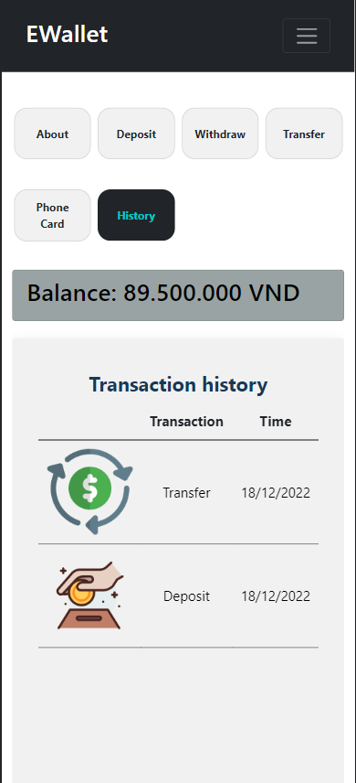

Figure . History Page Mobile